Semester Two Examination 2018 | 
Question/Answer Booklet

PHYSICS

12 ATAR

Student  Number: | In  Figures | 
YOUR  NAME | In words

Time allowed for this paper
Reading time before commencing work: Ten minutes
Working time for paper: Three hours

Materials required/recommended for this paper

To be provided by the supervisor

This Question/Answer Booklet/Formulae and Data Booklet

To be provided by the candidate
Standard items: pens (blue/black preferred), pencils (including coloured), sharpener, correction tape/fluid, eraser, ruler and highlighters
Special items: non-programmable calculators approved for use in this examination, drawing templates, drawing compass and a protractor

Important note to candidates

No other items may be taken into the examination room. It is your responsibility to ensure that you do not have any unauthorised material. If you have any unauthorised material with you, hand it to the supervisor before reading any further.

Structure of this paper
Section | Number of questions available | Number of questions to be answered | Suggested working time (minutes) | Marks available | Percentage of exam
Section One: Short answers | 11 | 11 | 50 | 54 | 30
Section Two: Problem-solving | X | X | 90 | 90 | 50
Section Three: Comprehension | Y | Y | 40 | 36 | 20
 |  |  | TOTAL | 180 | 100

Instructions to candidates

- The rules for the conduct of the Western Australian Certificate of Education ATAR course examinations are detailed in the Year 12 Information Handbook 2018. Sitting this examination implies that you agree to abide by these rules.

- Write your answers in this Question/Answer booklet.

- When calculating or estimating answers, show all your working clearly. Your working should be in sufficient detail to allow your answers to be checked readily and for marks to be awarded for reasoning.

In calculations, give final answers to three significant figures and include appropriate units where applicable.

In estimates, give final answers to a maximum of two significant figures and include appropriate units where applicable.

- You must be careful to confine your answers to the specific questions asked and to follow any instructions that are specific to a particular question.

- Additional working space pages at the end of this Question/Answer booklet are for planning or continuing an answer. If you use these pages, indicate at the original answer, the page number it is planned/continued on and write the question number being planned/continued on the additional working space page.

- The Formulae and Data booklet is not to be handed in with your Question/Answer booklet.

Additional Data

Section One. Short responses. 30% (54 Marks)

Attempt ALL ELEVEN (11) questions in this section.
Marks for each question are clearly identified.
________________________________________________________________

Question 1 (6 marks)

a) If the mass of the Earth was doubled and its radius was also doubled, then the
new value for the acceleration due to gravity on Earth would be (circle only one correct
answer below) and show working in the box. [3 marks]

(A) 0.5g

(B) g

(C) 2g

(D) 4g

b) An aurora is the appearance of brilliant coloured 'curtains' of light in the sky near the
north and south poles. Carefully explain using physics principles how and why these
phenomenon occur. [3 marks]

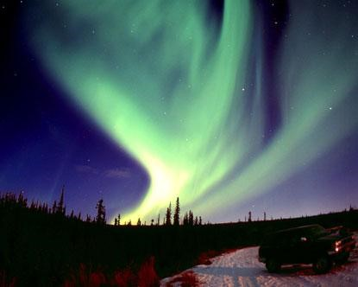

Question 2 (4 marks)

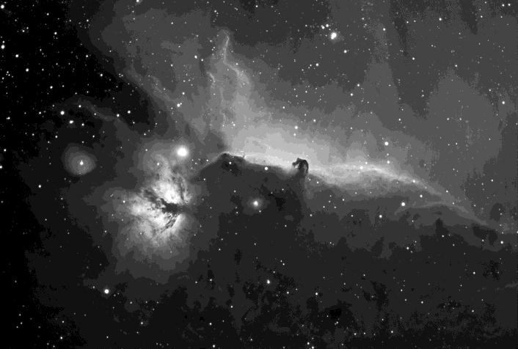
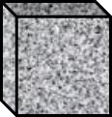
An astronaut is floating freely in space in the Orion Nebula.

W
₀

H
0

L
0

The astronaut is stationary and the view in the diagram (shown right) is what he sees from his faceplate.

A “Borg” spaceship, in the form of a cube with side length 5 km, is travelling at 20% of the speed of light (i.e. 0.2c) and is on a heading directly towards the astronaut.

The dimensions of the Borg ship are labelled L_{o}, W_{o}, and H_{o} in the diagram.

a) Which of the following options best describes the dimensions (L, W and H) of the box as
observed by the astronaut outside the spaceship compared to the measurements made
by the passenger?
- L< L_{o}, W < W_{o}, H = H_{o}
- L> L_{o}, W = W_{o}, H = H_{o}
- L< L_{o}, W = W_{o}, H = H_{o}
- L< L_{o}, W < W_{o}, H < H_{o} Answer: ______ [1 mark]

b) Carefully explain why you selected your answer. [3 marks]

Question 3 (7 marks)

Towards the end of the 20th century scientists suggested that quarks were the basic building blocks of protons and neutrons. Quarks have the following properties:

- They have mass.
- They can have electromagnetic charges of +1/3, +2/3, -1/3 and -2/3
- They have colour charge.
- They have spin.

a) Protons and Neutrons are each made up of 3 quarks. List the charges on each
quark for both particles. [2 marks]

Proton
Neutron

b) Briefly justify your answer. [1 mark]
c) Classify the following sub-atomic particles as either Hadrons, Leptons or Neither.

Proton |  | Neutrino
Muon |  | Photon

[2 marks]

d) A member of the ∑ group of particles consists of two u quarks and an s quark.
What is its charge? [2 marks]

Question 4 (3 marks)

An electron microscope uses a “magnetic lens” to focus a wide beam of electrons to a
point as shown in the diagram. Assume that all electrons have the same speed.
B1
- Illustrate the directions of the
magnetic fields B1 and B2 inside the triangular “magnetic” lenses

[1 mark]

B2

b) Calculate the deflecting force on electrons travelling with a velocity of
1.50 x 10⁶ ms⁻¹ if the magnetic field strength is 0.100 T. [2 marks]

Question 5 (4 marks)

A free body diagram shows all the forces exerted on a body and how they relate to each other and the resultant force on the body. Construct a clearly labelled free body diagram of an athlete running around a bend.

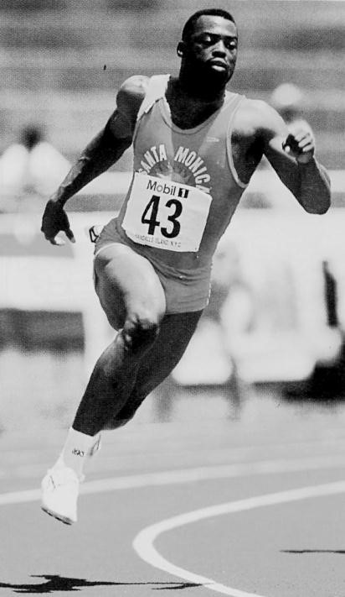

Question 6 (4 marks)

Estimate the force that is exerted on each arm when you execute a perfect push-up. You must provide all the relevant data and state all reasonable assumptions in determining your answer. (show all working details)

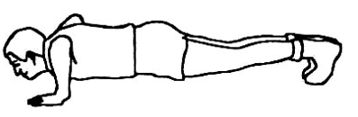

Question 7 (8 marks)

The spacecraft “Dawn” was launched on 27 September 2007 and will reach the dwarf planet (asteroid) Ceres in 2015. Ceres has a mass of 9.40 x 10²⁰ kg, radius of 480 km and rotates with a period of 9.07 hours.
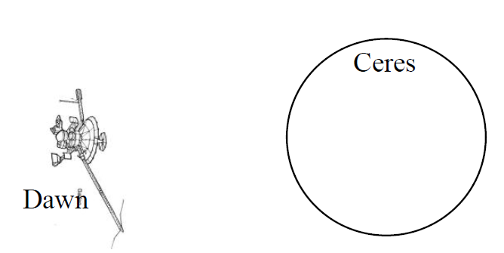
a) At what altitude above the surface would the
spacecraft need to orbit in order to remain in
a fixed position relative to the planet’s
surface? [4 marks]

b) Would this orbit be “geostationary”? Explain. [2 marks]

- An object moves in a circle in a counter-clockwise direction with constant
speed. On the diagram below draw and label the correct velocity and
acceleration vectors for the object. [2 marks]

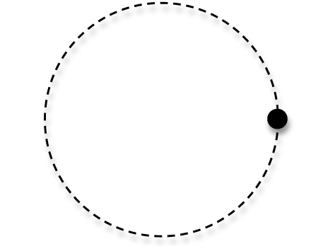

Question 8 (4 marks)

An alien spacecraft traveling at relativistic speed is flying overhead at a great distance as you stand in your backyard. You see its searchlight blink on for 0.190 s.

(a) Would an alien observer on the spacecraft measure the same time interval for the searchlight blinks that we measure on Earth? (1 mark)

(b) Would the time between blinks that we measure on Earth be longer or shorter than what the alien measures on the spacecraft? Explain your reasoning. (3 marks)

Question 9 (4 marks)

A current is sent through a helical coil spring, as shown in the diagram below. When the current is flowing the spring contracts, as though it had been compressed.

Explain why this is so. [Hint: Annotate and refer to the diagram in your answer or even draw an alternative diagram].

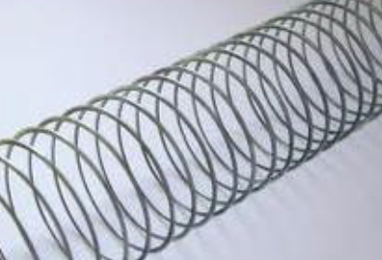

Question 10 (6 marks)

a) A beam of 35.0 keV electrons strike a molybdenum target, generating X-rays.
Determine the cut-off wavelength ( λmin). [3 marks]

- The wavelength of the H_{β} line in the spectrum of the star Megrez in the constellation Ursa Major (the Great Bear) is 486.112 nm. Laboratory measurements demonstrate that the normal wavelength of this spectral line is 486.133 nm. Is the star coming towards us or moving away from us? Justify your answer. [3 marks]

Question 11 (4 marks)

Hundreds of thousands of asteroids orbit the sun within the asteroid belt, which extends from about 3.00 x 10⁸ km to about 5.00 x 10⁸ km from the surface of the sun.

Assume the orbits are circular.

Determine the speed of an asteroid at the inside of the belt.



Extra page for additional working



